# 

**Review Circle Preparation Form**

**(Supervisor)**

# Round 1: What I have done well: Please think about what you would like to say and write your notes here:

# What do I do well in terms of my relationships?

* What do I do well in terms of my contributions to the environment?
* What do I do well in terms of facilitating positive, enriching, responsive, and/or novel experiences?

# Round 2: What I could do better: Please think about what you will say and write your notes here:

# What could I do better in terms of my relationships?

* What could I do better in terms of my contributions to the environment?
* What could I do better in terms of facilitating positive, enriching, responsive, and/or novel experiences?

**Round 3: Exploration of Improvement Areas:** What areas or dimensions need improvement (**not *how*** we want this to be improved). Examples may be time management, communication, relationships, attitude, etc. This will be based on all the information provided in the previous rounds and will be consented to by the circle. **This work will/can be done during the circle.**

**Round 4: Exploration of Improvement Plan:** The next part will be to brainstorm action step ideas. How would we like to see improvements in those areas? These must include **terms** and **measurements**. **This work can/will be done during the circle.**



**Performance Review Circle Summary for:**

**__________________________________**

**Please turn in to Programs Coordinator.**

**COLA Raise effective (DOH): _____/_____/______**

**Performance Review Circle Completed on ____/_____/______**

**Focus person Signature:_______________________________**

**Supervisor Signature: _________________________________**

**Programs Coordinator Signature: ___________________________**

**PLEASE TURN IN TO PAYROLL.**

# Round 1: Done Well:

# Round 2: Could do better: Please think about what you will say and write your notes here:

**Round 3: Exploration of Improvement Areas:**

**Round 4: Exploration of Improvement Plan:**

**Proposal with Consent:** Improvement Plan with terms and measurements:

|  |  |  |  |
| --- | --- | --- | --- |
| **Desired Result** | **Specific Goal** | **Measurement(s)** | **Term** |
|  |  |  |  |
|  |  |  |  |
|  |  |  |  |
|  |  |  |  |

# 

**Supplemental Merit Raise Request Form**

# Name:__________________ ____________ Date of Performance Review Circle: ___________

Job Title & Swing Level: ________________________ Facilitator: ________________________

Submit to Supervisor by: ________________ Submit to Office Assistant by: ________________

Return for Signatures by: ________________ Submit to Payroll by: ________________

All employees are given an annual Cost of Living Adjustment raise on the anniversary of their date of hire. This raise is based on a percentage of your current payrate as determined annually by the Board of Directors. The percentage is the same for all employees, regardless of tenure or performance.

All employees are afforded the opportunity to request an additional merit-based raise. Merit-based raises are reserved for those employees who consistently exceed the performance expectations for their position and experience level, have shown considerable growth and development, and/or have consistently met their professional goals.

Merit-based raises are granted at the discretion of the Performance Review Facilitator in conjunction with the Performance Review Circle and will take into consideration documented:

* Performance Review Circle input;
* Progress on goals,
* 1:1 documentation,
* Peer impact statements,
* Self-assessment.

\***Preparation of this form should not exceed .5 hours on your timesheet.**

Implications:

You must rank at least a 4 on all scales to qualify for a merit raise.

|  |  |
| --- | --- |
| Points | Eligible Percentage Increase |
| 22-24 | 3% |
| 20-21 | 2% |
| 18-19 | 1% |



**Relationships with Children**

**Supplemental Merit Raise Worksheet**

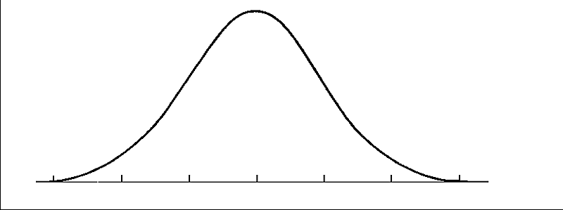

Examples of how you have met &/or exceeded your goals after the past year:

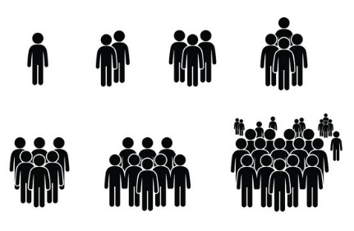



|  |  |  |  |
| --- | --- | --- | --- |
| 1  Does not meet expectations of standard fully and /or consistently | 2  Meets the expectation fully and consistently | 3  Exceeds the expectation frequently | 4  Exceeds the expectation fully and consistently |

Self Score (1-4) _______

Leader Score (1-4) _______

**Relationships with Families**



Examples of how you have met &/or exceeded your goals after the past year:





|  |  |  |  |
| --- | --- | --- | --- |
| 1  Does not meet expectations of standard fully and /or consistently | 2  Meets the expectation fully and consistently | 3  Exceeds the expectation frequently | 4  Exceeds the expectation fully and consistently |

Self Score (1-4) _______

Leader Score (1-4) _______

**Relationships with Staff**



Examples of how you have met &/or exceeded your goals after the past year:





|  |  |  |  |
| --- | --- | --- | --- |
| 1  Does not meet expectations of standard fully and /or consistently | 2  Meets the expectation fully and consistently | 3  Exceeds the expectation frequently | 4  Exceeds the expectation fully and consistently |

Self Score (1-4) _______

Leader Score (1-4) _______

**Environmental Contributions**



Examples of how you have met &/or exceeded your goals after the past year:





|  |  |  |  |
| --- | --- | --- | --- |
| 1  Does not meet expectations of standard fully and /or consistently | 2  Meets the expectation fully and consistently | 3  Exceeds the expectation frequently | 4  Exceeds the expectation fully and consistently |

Self Score (1-4) _______

Leader Score (1-4) _______

**Cultivating Experiences**



Examples of how you have met &/or exceeded your goals after the past year:





|  |  |  |  |
| --- | --- | --- | --- |
| 1  Does not meet expectations of standard fully and /or consistently | 2  Meets the expectation fully and consistently | 3  Exceeds the expectation frequently | 4  Exceeds the expectation fully and consistently |

Self Score (1-4) _______

Leader Score (1-4) _______

**Professionalism / Work Habits**



Examples of how you have met &/or exceeded your goals after the past year:





|  |  |  |  |
| --- | --- | --- | --- |
| 1  Does not meet expectations of standard fully and /or consistently | 2  Meets the expectation fully and consistently | 3  Exceeds the expectation frequently | 4  Exceeds the expectation fully and consistently |

Self Score (1-4) _______

Leader Score (1-4) _______