# 

**Supplemental Merit Raise Request Form**

# Name:__________________ ____________ Date of Performance Review Circle: ___________

Job Title & Swing Level: ________________________ Facilitator: ________________________

Submit to Supervisor by: ________________ Submit to Office Assistant by: ________________

Return for Signatures by: ________________ Submit to Payroll by: ________________

All employees are given an annual Cost of Living Adjustment raise on the anniversary of their date of hire. This raise is based on a percentage of your current payrate as determined annually by the Board of Directors. The percentage is the same for all employees, regardless of tenure or performance.

All employees are afforded the opportunity to request an additional merit-based raise. Merit-based raises are reserved for those employees who consistently exceed the performance expectations for their position and experience level, have shown considerable growth and development, and/or have consistently met their professional goals.

Merit-based raises are granted at the discretion of the Performance Review Facilitator in conjunction with the Performance Review Circle and will take into consideration documented:

* Performance Review Circle input;
* Progress on goals,
* 1:1 documentation,
* Peer impact statements,
* Self-assessment.

\***Preparation of this form should not exceed .5 hours on your timesheet.**

Implications:

You must rank at least a 4 on all scales to qualify for a merit raise.

|  |  |
| --- | --- |
| Points | Eligible Percentage Increase |
| 22-24 | 3% |
| 20-21 | 2% |
| 18-19 | 1% |



**Relationships with Children**

**Supplemental Merit Raise Worksheet**

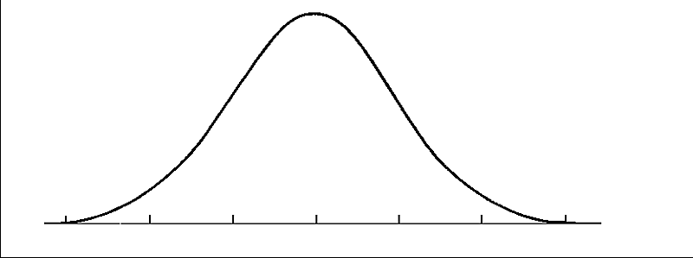

Examples of how you have met &/or exceeded your goals after the past year:

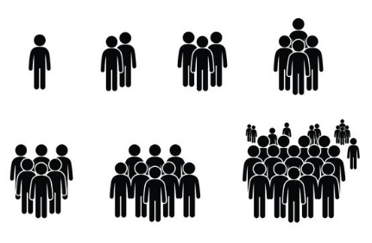



|  |  |  |  |
| --- | --- | --- | --- |
| 1  Does not meet expectations of standard fully and /or consistently | 2  Meets the expectation fully and consistently | 3  Exceeds the expectation frequently | 4  Exceeds the expectation fully and consistently |

Self Score (1-4) _______

Leader Score (1-4) _______

**Relationships with Families**



Examples of how you have met &/or exceeded your goals after the past year:





|  |  |  |  |
| --- | --- | --- | --- |
| 1  Does not meet expectations of standard fully and /or consistently | 2  Meets the expectation fully and consistently | 3  Exceeds the expectation frequently | 4  Exceeds the expectation fully and consistently |

Self Score (1-4) _______

Leader Score (1-4) _______

**Relationships with Staff**



Examples of how you have met &/or exceeded your goals after the past year:





|  |  |  |  |
| --- | --- | --- | --- |
| 1  Does not meet expectations of standard fully and /or consistently | 2  Meets the expectation fully and consistently | 3  Exceeds the expectation frequently | 4  Exceeds the expectation fully and consistently |

Self Score (1-4) _______

Leader Score (1-4) _______

**Environmental Contributions**



Examples of how you have met &/or exceeded your goals after the past year:





|  |  |  |  |
| --- | --- | --- | --- |
| 1  Does not meet expectations of standard fully and /or consistently | 2  Meets the expectation fully and consistently | 3  Exceeds the expectation frequently | 4  Exceeds the expectation fully and consistently |

Self Score (1-4) _______

Leader Score (1-4) _______

**Cultivating Experiences**



Examples of how you have met &/or exceeded your goals after the past year:





|  |  |  |  |
| --- | --- | --- | --- |
| 1  Does not meet expectations of standard fully and /or consistently | 2  Meets the expectation fully and consistently | 3  Exceeds the expectation frequently | 4  Exceeds the expectation fully and consistently |

Self Score (1-4) _______

Leader Score (1-4) _______

**Professionalism / Work Habits**



Examples of how you have met &/or exceeded your goals after the past year:





|  |  |  |  |
| --- | --- | --- | --- |
| 1  Does not meet expectations of standard fully and /or consistently | 2  Meets the expectation fully and consistently | 3  Exceeds the expectation frequently | 4  Exceeds the expectation fully and consistently |

Self Score (1-4) _______

Leader Score (1-4) _______