# Snack Area

Talk Nutrition and Practice Table Manners

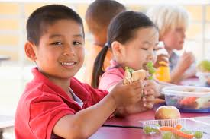

Talk Quietly Please

Please Sit Down

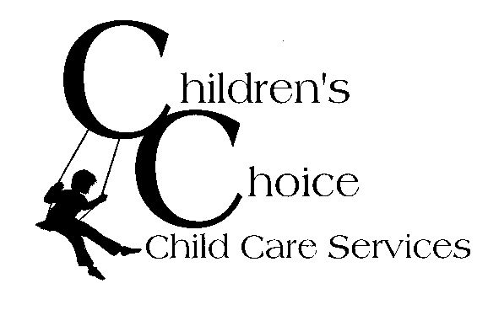to Eat!

# Snack Area

Talk Nutrition and Practice Table Manners

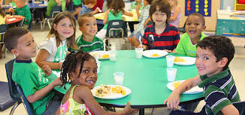Talk Quietly Please

Please Sit Down

to Eat!

