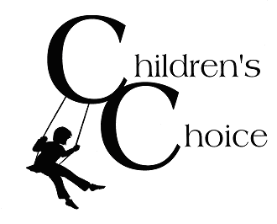

Hey Kids,

We want to know what YOU think we are doing well and what we could do better. We
would greatly appreciate your input!!

Please answer each question with an X in the appropriate box.
 | Yes Sometimes No
1. I feel safe at Children’s Choice. |      
2. I have friends at Children’s Choice. |      
3. There are adults who care about me at Children’s Choice. |      
4. I like the activities at Children’s Choice. |       
5. Kids learn from the activities at Children’s Choice. |       
6. The staff listen to the kids at Children’s Choice. |       
7. The staff are fair to everyone at Children’s Choice. |       
8. The staff help kids when there are problems at Children’s Choice. |       
9. The staff help kids learn what to do when they feel upset or  frustrated. |       
10. The staff help teach kids how to get along. |       
11. The staff teach kids how to solve problems at Children’s Choice. |       
12. I like coming to Children’s Choice. |       

Just for kids ages 9-12: | Yes Sometimes No
13. I get to do things separately and different  from the younger kids. |       
14. The staff treat me my age. |       
15. I get to do things outside the program like  field trips, community service, etc. |       
My favorite part of coming to Children’s Choice is:

If I could change something about Children’s Choice it would be:

Thanks a lot!!

