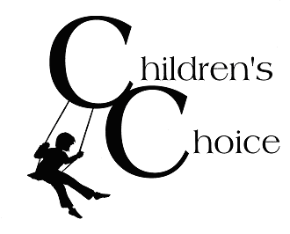

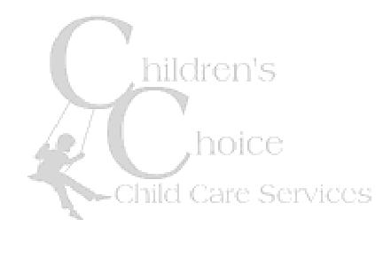
Dear Families,

We are looking at the quality of our program to learn what we are doing well and what we could do better. We would greatly appreciate your input!

1. What is one thing that we could most improve on?

2. What is one thing we do really well?

Please answer each question with an x in the appropriate box.
 | Yes Sometimes No Unsure
3. My child feels safe at Children’s Choice. |        
4. My child enjoys attending Children’s Choice. |        
5. My child feels connected to other kids at Children’s Choice. |        
6. Children’s Choice has helped my child learn to make friends. |        
7. Being part of Children’s Choice has helped my child manage stress  and frustrations. |        
8. Being a part of Children’s Choice has helped my child approach  challenges with more confidence. |        
11. The program staff handle behavior management in a way that I am  comfortable with. |        
12. The program space is clean, organized and inviting. |        
13. I am greeted by a staff member each time I enter  the program. |        
14. I feel free to visit the program and offer my ideas,  suggestions, and concerns at any time. |        
15. I am kept informed about the program. |        
16. I am familiar with the policies and philosophies of the  program. |        
17. I would recommend Children’s Choice to others. |        

Anything else you would like us to know:

Thank you!

