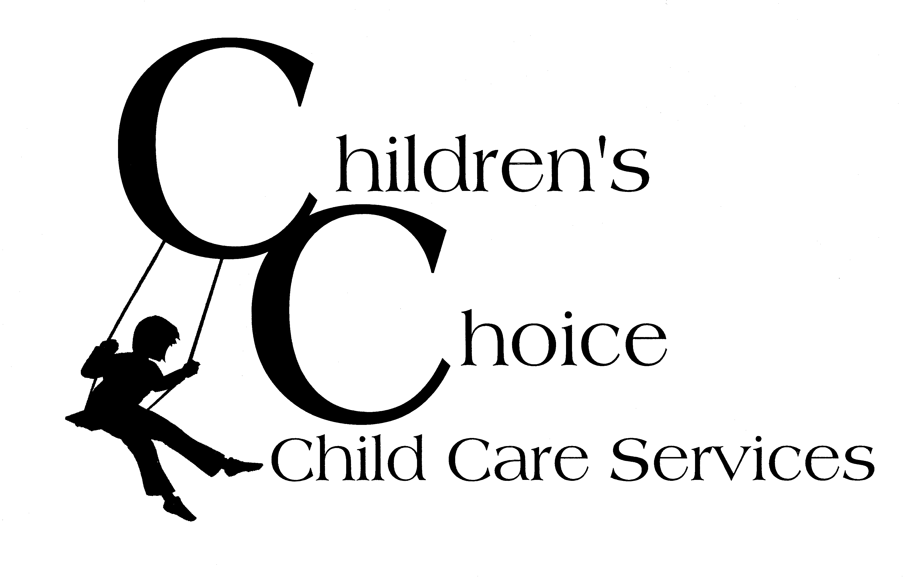
Request for Administration of Medications

Name of child:________________________________________________ Date of birth:_______________

Type of Medication: Prescription Non-prescription

Name of Medication:____________________________Instructions: Dosage and times:__________________________________

Dates medication is to be administered: Starting:______________ Ending:______________

I request that the school-age care program staff administer the above medication and I release the staff and the agency from any liability resulting from the administration of the above medication(s).

_______________________________ ___________
Parent or Legal Guardian’s Signature Date

Medication | Dosage | Date | Time | Staff Initials | Child’s Initials | Parent’s Initials

Medication Policy: A program will keep all medications in a locked and identified container inaccessible to children and will refrigerate medications when necessary. If the area where medications are stored is accessible to children, medications must be kept in a locked container. Programs will give medication only with written permission from at least one parent, to be administered according to written directions from the prescribing physician. In the case of non-prescription medication, the parent must provide written instructions. A designated staff member will be responsible for giving medication to children. The designated staff member will ensure non-prescription and prescription medications have a label with the child's name and the date the medication was brought to the program. A program will keep non-prescription and prescription medication in the original container with written instructions, including the name of medication, the dosage, and the hours and dates the child should receive the medicine. The designated staff member will keep a written record of the dosage, date, and time a child is given medication with the signature of the staff who administered the medication. This information will be provided to the parent who will initial/date acknowledgment of the information received on the day the medication is given. When the medication is no longer needed, it shall be returned to the parents or destroyed. The program shall not administer expired medication.

